# Lab 4. Task 1- preparation task Template for answers

**Save this document as a .pdf document before submitting.**

*Student names and LiU-IDs: (Max 2 students per group):*

*1. Cindy Khuong, cinkh090*

*2. Rebecca Sjödin, rebsj192*

*Submission date: 21-12-10*

*Version (in case you need to re-submit): 1*

1. **Hough transform**

**1)** H1:

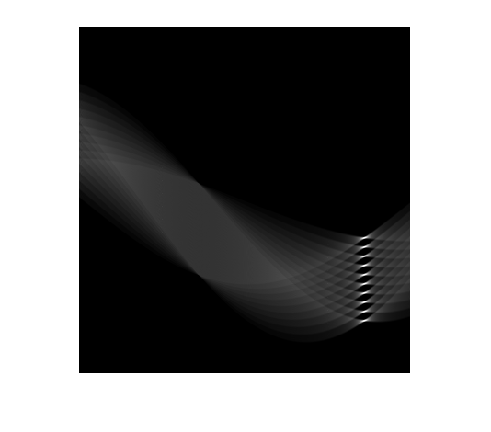

**2)** Your guess:

70 degrees

**3)** What is the exact angle corresponding to the lines in $Image1a$?

65 degrees

**4)** What is the angle of **clockwise** rotation to rotate $Image1a$ to the horizontal level? Use your answer from problem 3.

90-65 = 25 degrees (we rotated with -25, clockwise rotation)

**5)** Image1a_rotated:

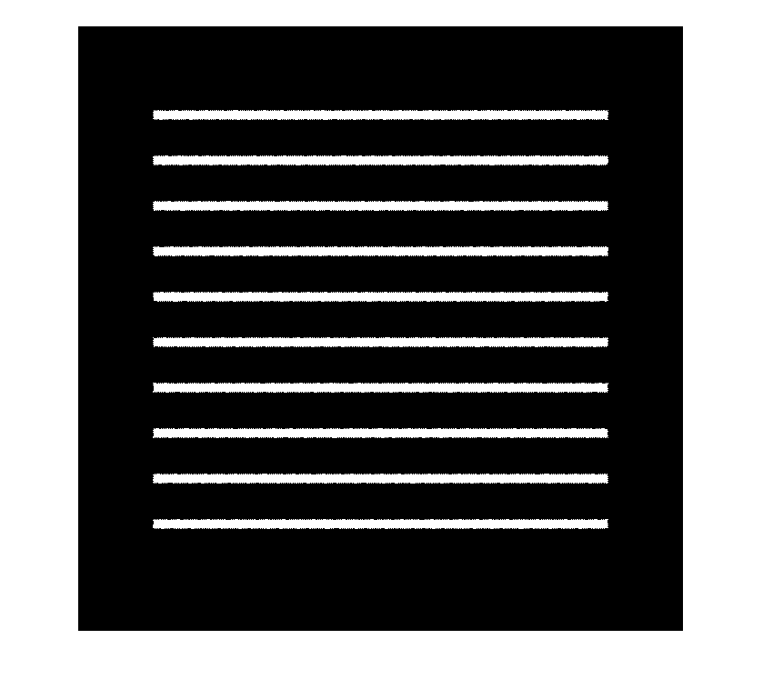

**6)** What is the exact angle corresponding to the straight lines in $Image1b$?

*-75 degrees*

**7)** What is the angle of **counterclockwise** rotation to rotate $Image1b$ to horizontal level? Use your answer from problem 6.

15 degrees (positive because of counterclockwise rotation)

**8)** Image1b_rotated:

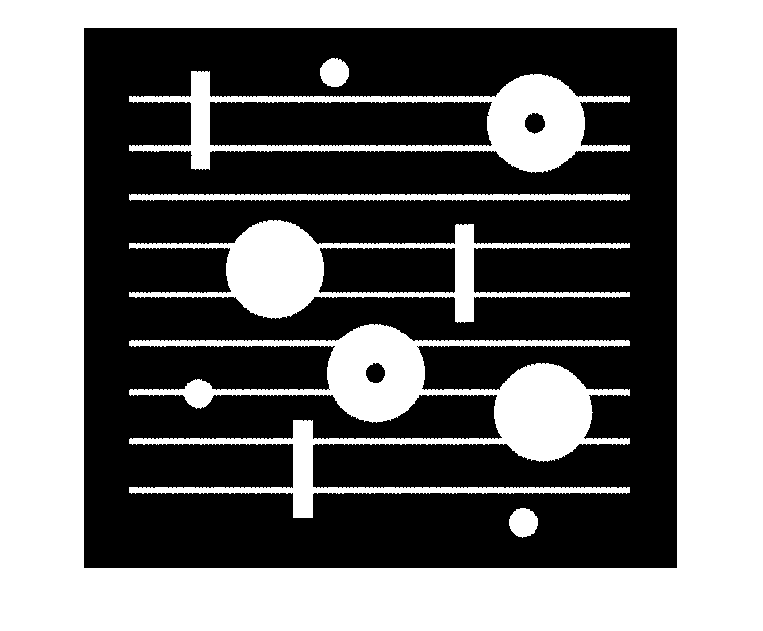

**9)** Image1c with noise removed:

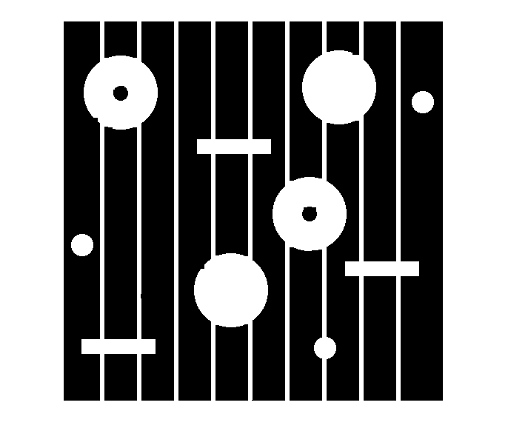

**10)** Image1c_clean (noise and lines removed):

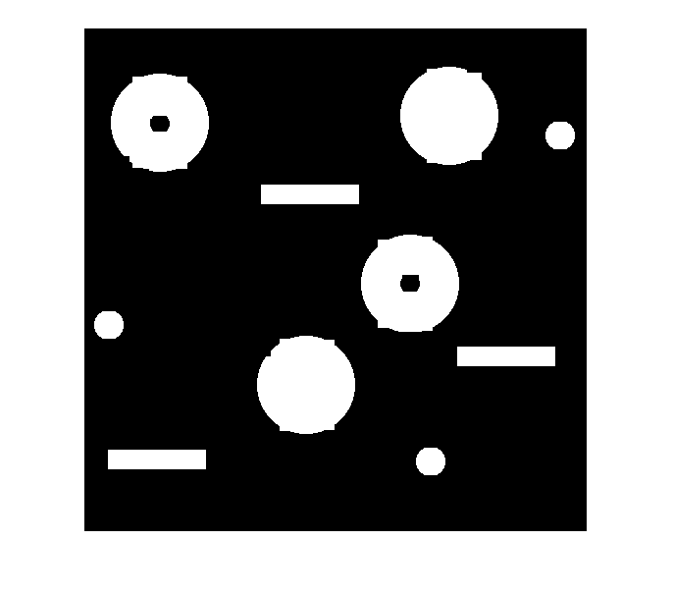

**11)** RGB-image displaying the 3 different classes of objects in different colors:

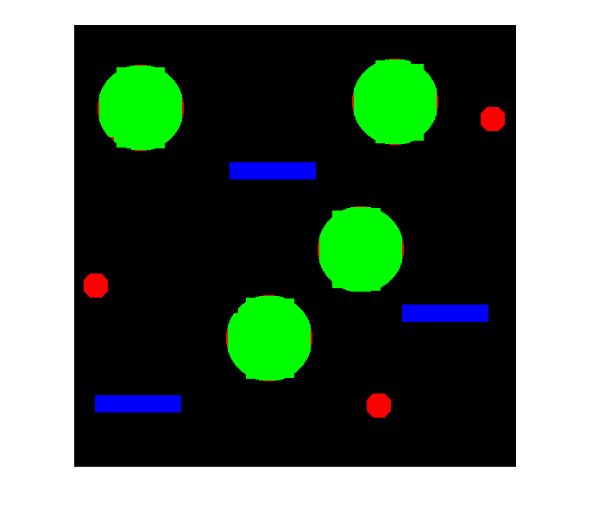

**12)** Your structuring element: SE = strel(…)

Segmented image with all the grains of rice:

SE5 = strel("disk",15);

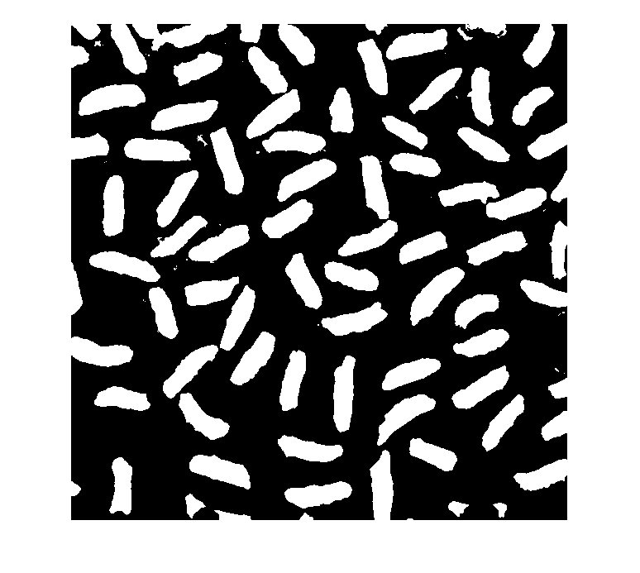

**13)** Labeled image, L, scaled by max value:

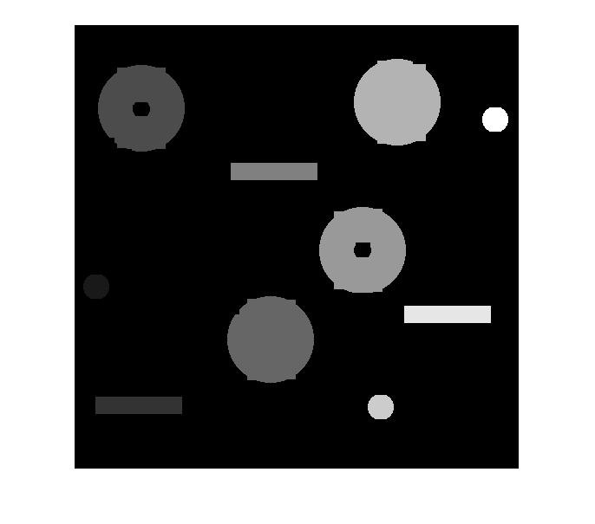

**14)** What are the perimeters for the large objects (having area > 3000 pixels)?

Image containing only the large objects:

Perimeter: 327.4740, 325.6300, 323.8520, 324.9850

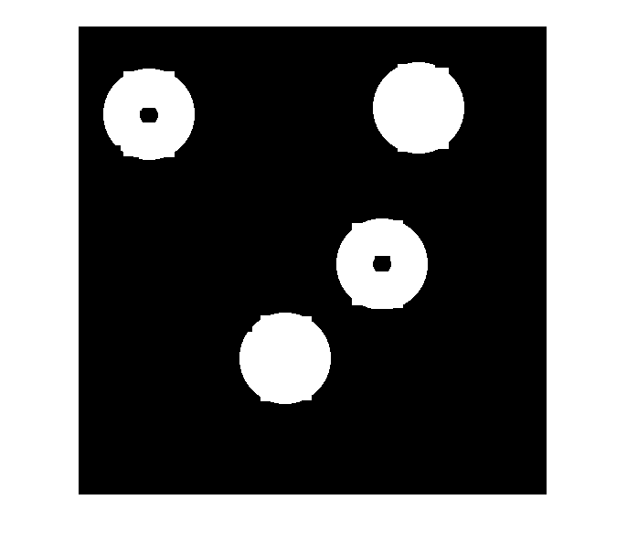

**15)** What is your selected threshold value?

What are the labels of the objects belonging to the class with the smallest perimeter?

Threshold value is 130.

Labels is [1 8 10]

**16)** What are the labels of the objects belonging to the class with the largest perimeter, and that has no holes?

Image containing only objects having the largest perimeter, without holes:

Labels: [3 4 6 7]

Labels without holes: [4 7]

*Don’t forget to save the document as* ***.pdf*** *before submitting!*